- Read a water-tank level percentage and display Empty, Low, Medium, High, or Full.
Display Digits from Left to Right
Problem Statement
Read the water tank level percentage and display empty , low , medium ,high or full.
Aim:
To read the water tank level percentage and display empty , low , medium ,high or full.

Flowgorithm Logic:
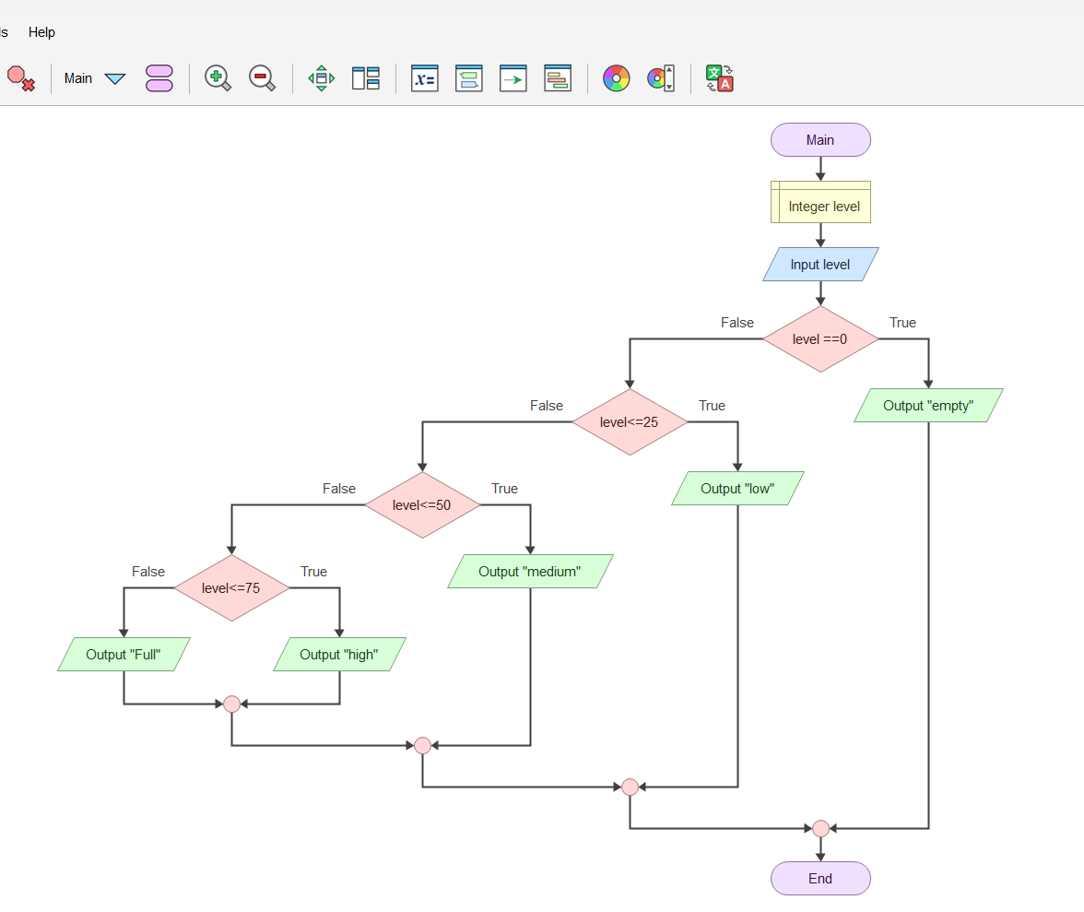

Pseudo code
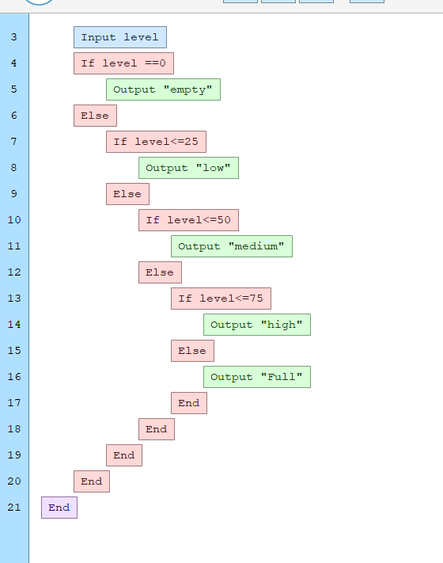
Java code:
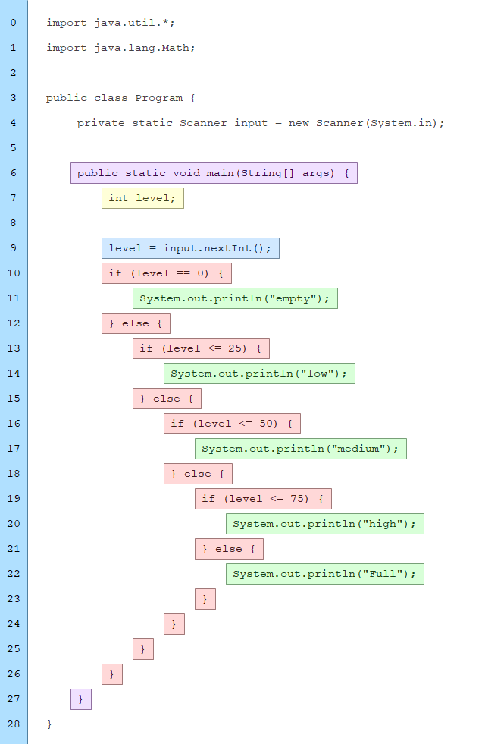
output
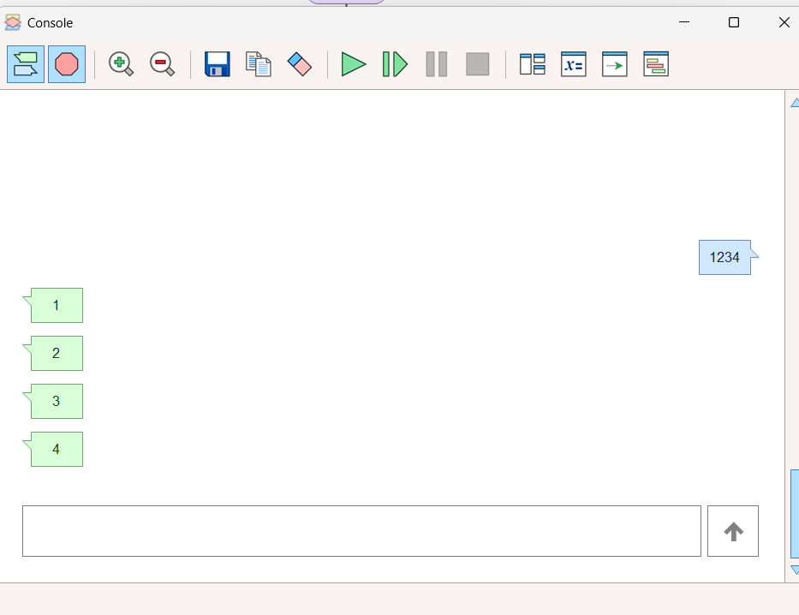

Result:
The program successfully displays the water tank level is emplty , medium , full , or high .

2) Design a restaurant-billing flowchart with DineIn, TakeAway, and Delivery order types. Apply different service or delivery charges and relate the logic to overriding.
Restaurant Billing System (DineIn, TakeAway, Delivery)
Aim:
To design a restaurant billing system that calculates the final bill based on DineIn, TakeAway, or Delivery order types with different service and delivery charges.

Flowgorithm Logic

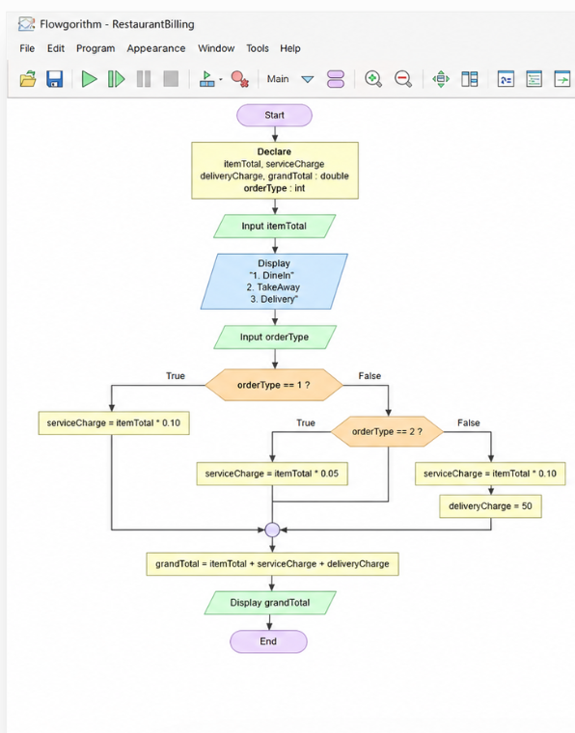

Java Code
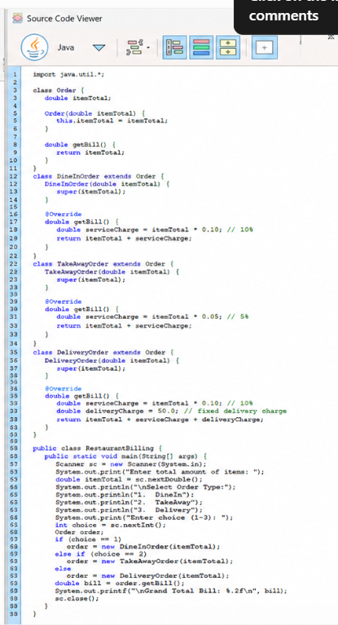
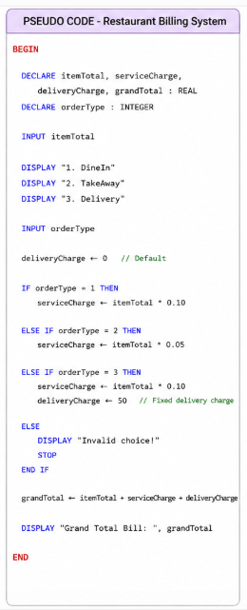
Pseudo code

Output
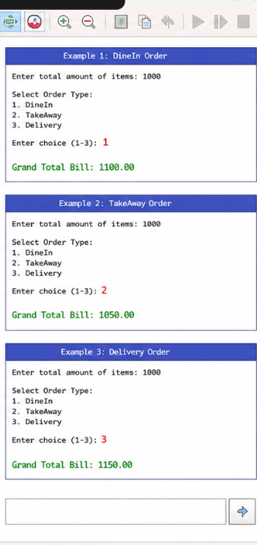

Result:
The program correctly calculates and displays the final restaurant bill according to the selected order type and applicable charges.

3)Read an integer and determine whether its absolute value is less than 10, between 10 and 99, or at least 100.
Problem Statement
Read an integer and determine whether its absolute value is:
- Less than 10
- Between 10 and 99
- At least 100

Aim:
To read an integer and classify it based on the magnitude of its absolute value.

Flowgorithm Logic
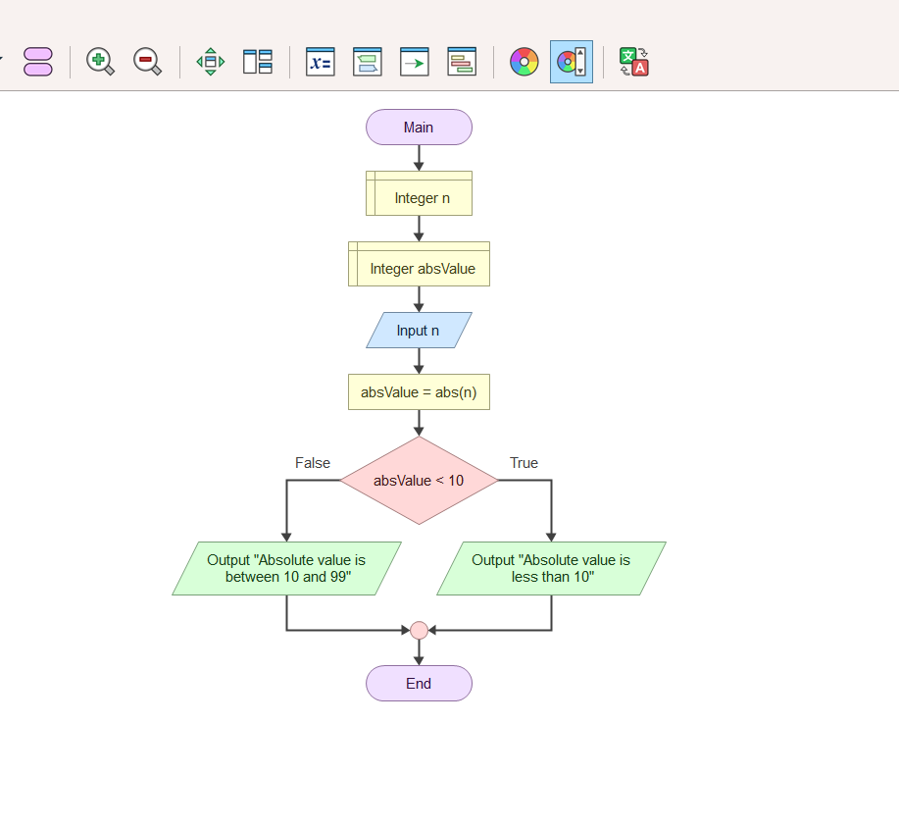

Pseudo code
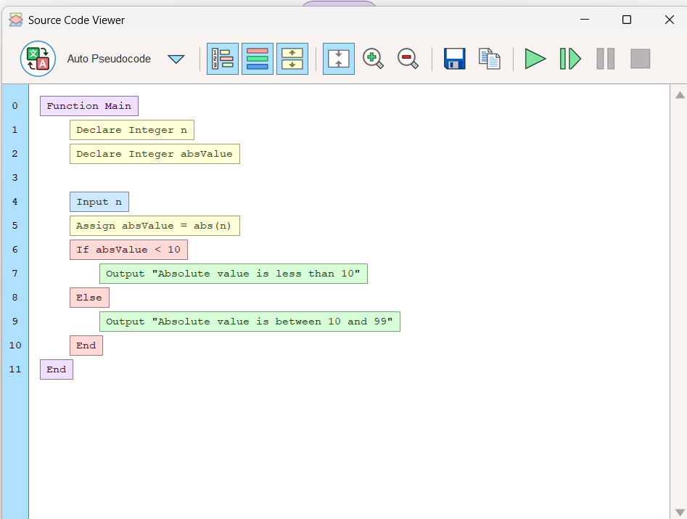

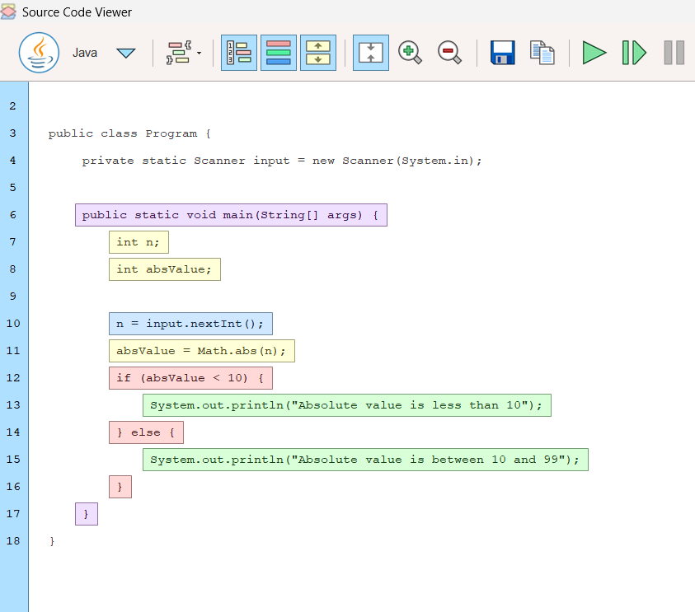
java code

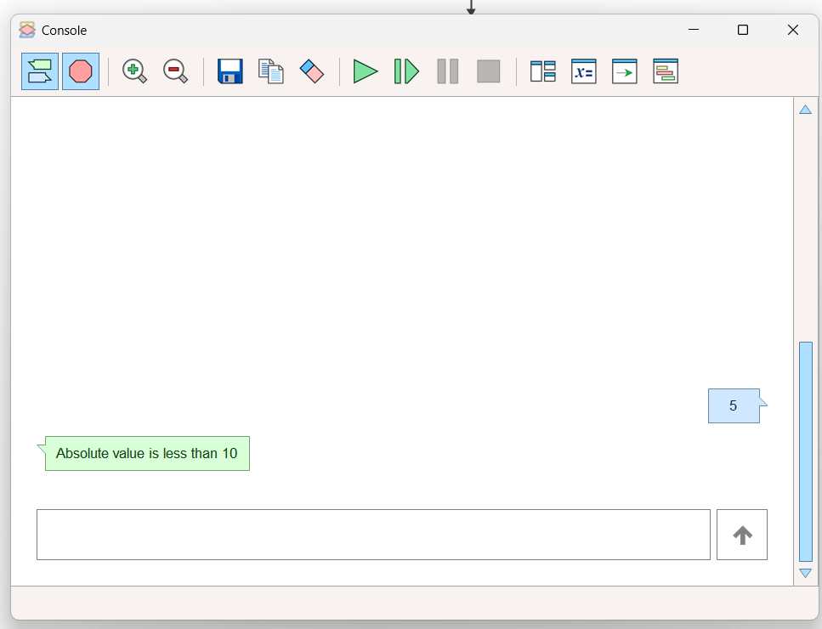
output-

Result:
The program successfully determines and displays the correct category of the entered integer based on its absolute value.

